A
PRACTICAL FILE
ON

OPERATING SYSTEM (CS-405)

SUBMITTED PARTIAL FULFILMENT OF THE REQUIREMENT FOR THE
AWARD OF
THE DEGREE OF
BACHELOR OF TECHNOLOGY
(COMPUTER SCIENCE & ENGINEERING)

SUBMITTED TO
RAJIV GANDHI PROUDYOGIKI VISHWAVIDYALAYA,BHOPAL


SUBMITTED TO: SUBMITTED BY:
Mr.Vineet Raj Singh Kushwah Sneha Kushwah
Ass. Professor Enroll no. 0928CS221128
Dept. of CSE II year/ IV semester

Department of Computer Science & Engineering
IPS COLLEGE OF TECHNOLOGY AND MANAGEMENT ,GWALIOR
May 2024
content
S.NO. | TITLE OF EXPERIMENT | PAGE NO. | SIGN.
1. | .Write program to FCFS CPU scheduling
2. | .Write program to SJF CPU scheduling
3. | .Write program to RR CPU scheduling.
4. | .Write program to Priority CPU scheduling
5.
6.
7.
8.
9. | .
10.

1.Write program toFCFS CPU sceduling.

import java.util.*;

/**
* fcfs
*/
public class fcfs {

public static void main(String[] args) {
int id[]=new int[25];
int bt[]=new int[25];
int at[]=new int[25];
int ct[]=new int[25];
int var;
Scanner ob=new Scanner(System.in);
System.out.println("enter the no. of process");
int n=ob.nextInt();
for(int i=0;i<n;i++){
System.out.println("enter the process id ande burst time and arrival time of process "+ i);
id[i]=ob.nextInt();
bt[i]=ob.nextInt();
at[i]=ob.nextInt();

}
int sum=at[0];
for(int i=0;i<n;i++){
sum+=bt[i];
ct[i]=sum;
}
int tat[]=new int[25];
int wt[]=new int[25];
float avgWt=0;
for(int i=0;i<n;i++){
tat[i]=ct[i]-at[i];
wt[i]=tat[i]-bt[i];
avgWt+=wt[i];
}
avgWt/=n;
System.out.print("pId\tbt\tat\tct\ttat\twt\t\n");
for(int i=0;i<n;i++){
System.out.print(id[i]+"\t"+bt[i]+"\t"+at[i]+"\t"+ct[i]+"\t"+tat[i]+"\t"+wt[i]+"\n");
}

System.out.println(avgWt);
}
}

There is output
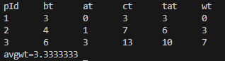

2. Write program to SJF CPU sceduling.
import java.util.Scanner;

public class sjf {
public static void main(String[] args) {
Scanner ob=new Scanner(System.in);
System.out.println("enter the no. of process");
int n=ob.nextInt();
int id[]=new int[25];
int bt[]=new int[n];
int at[]=new int[25];
int ct[]=new int[25];

for(int i=0;i<n;i++){
System.out.println("enter the process id ande burst time and arrival time of process "+ i);
id[i]=ob.nextInt();
bt[i]=ob.nextInt();
at[i]=ob.nextInt();

}
for(int i=0;i<bt.length;i++){
for(int j=0;j<bt.length-i-1;++j){
if(bt[j]>bt[j+1])
{
int temp=bt[j];
bt[j]=bt[j+1];
bt[j+1]=temp;
}
}
}

float avgWt=0;
int wt[]=new int [25];
wt[0]=0;
for(int i=1;i<n;i++){
wt[i]=bt[i-1]+wt[i-1];
avgWt+=wt[i];
}
int tat[]=new int[25];
for(int i=0;i<n;i++){
tat[i]=bt[i]-at[i]; }
avgWt/=n;
System.out.print("pId\tbt\tat\ttat\twt\t\n");
for(int i=0;i<n;i++){
System.out.print(id[i]+"\t"+bt[i]+"\t"+at[i]+"\t"+"\t"+tat[i]+"\t"+wt[i]+"\n");
}

System.out.println(avgWt);
}}

There is output ....
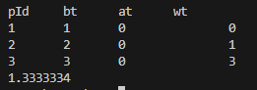

3. Write program to RR CPU sceduling

public class GFG
{

static void findWaitingTime(int processes[], int n,
int bt[], int wt[], int quantum)
{

int rem_bt[] = new int[n];
for (int i = 0 ; i < n ; i++)
rem_bt[i] = bt[i];

int t = 0; // Current time

while(true)
{
boolean done = true;

for (int i = 0 ; i < n; i++)
{

if (rem_bt[i] > 0)
{
done = false;

if (rem_bt[i] > quantum)
{
sed
t += quantum;

rem_bt[i] -= quantum;
}

ss
else
{

t = t + rem_bt[i];

wt[i] = t - bt[i];

rem_bt[i] = 0;
}
}
}

if (done == true)
break;
}
}

static void findTurnAroundTime(int processes[], int n,
int bt[], int wt[], int tat[])
{

for (int i = 0; i < n ; i++)
tat[i] = bt[i] + wt[i];
}

/
static void findavgTime(int processes[], int n, int bt[],
int quantum)
{
int wt[] = new int[n], tat[] = new int[n];
int total_wt = 0, total_tat = 0;

findWaitingTime(processes, n, bt, wt, quantum);

findTurnAroundTime(processes, n, bt, wt, tat);

System.out.println("PN " + " B " +
" WT " + " TAT");

for (int i=0; i<n; i++)
{
total_wt = total_wt + wt[i];
total_tat = total_tat + tat[i];
System.out.println(" " + (i+1) + "\t\t" + bt[i] +"\t " +
wt[i] +"\t\t " + tat[i]);
}

System.out.println("Average waiting time = " +
(float)total_wt / (float)n);
System.out.println("Average turn around time = " +
(float)total_tat / (float)n);
}

public static void main(String[] args)
{
// process id's
int processes[] = { 1, 2, 3};
int n = processes.length;

int burst_time[] = {10, 5, 8};

int quantum = 2;
findavgTime(processes, n, burst_time, quantum);
}
}

There is output ...........
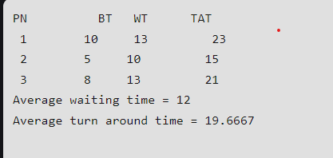

4. Write program to priority CPU sceduling
#include <bits/stdc++.h>
using namespace std;
struct Process {
int pid; // Process ID
int bt; // CPU Burst time required
int priority; // Priority of this process
};
bool comparison(Process a, Process b)
{
return (a.priority > b.priority);
}
void findWaitingTime(Process proc[], int n, int wt[])
{
wt[0] = 0;
for (int i = 1; i < n; i++)
wt[i] = proc[i - 1].bt + wt[i - 1];
} void findTurnAroundTime(Process proc[], int n, int wt[],
int tat[])
{ for (int i = 0; i < n; i++)
tat[i] = proc[i].bt + wt[i]; }
void findavgTime(Process proc[], int n)
{ int wt[n], tat[n], total_wt = 0, total_tat = 0;
findWaitingTime(proc, n, wt);
findTurnAroundTime(proc, n, wt, tat);
cout << "\nProcesses "
<< " Burst time "
<< " Waiting time "
<< " Turn around time\n";
for (int i = 0; i < n; i++) {
total_wt = total_wt + wt[i];
total_tat = total_tat + tat[i];
cout << " " << proc[i].pid << "\t\t" << proc[i].bt
<< "\t " << wt[i] << "\t\t " << tat[i]
<< endl; }
cout << "\nAverage waiting time = "
<< (float)total_wt / (float)n;
cout << "\nAverage turn around time = "
<< (float)total_tat / (float)n; }
void priorityScheduling(Process proc[], int n) {
sort(proc, proc + n, comparison);
cout << "Order in which processes gets executed \n";
for (int i = 0; i < n; i++)
cout << proc[i].pid << " ";
findavgTime(proc, n);
}
int main()
{
Process proc[]
= { { 1, 10, 2 }, { 2, 5, 0 }, { 3, 8, 1 } };
int n = sizeof proc / sizeof proc[0];
priorityScheduling(proc, n);
return 0;
}
There is output

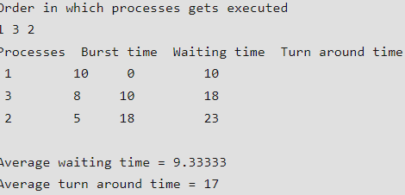

import java.util.LinkedList; import java.util.Queue;

public class FifoQueue {
public static void main(String[] args) { Queue<Integer> queue = new LinkedList<>(); queue.add(1);
queue.add(2);
queue.add(3);
queue.add(4);
queue.add(5);

System.out.println("Initial queue: " + queue);

while (!queue.isEmpty()) {
int removedElement = queue.poll();
System.out.println("Removed element: " + removedElement); System.out.println("Queue after removal: " + queue);
}
}
}

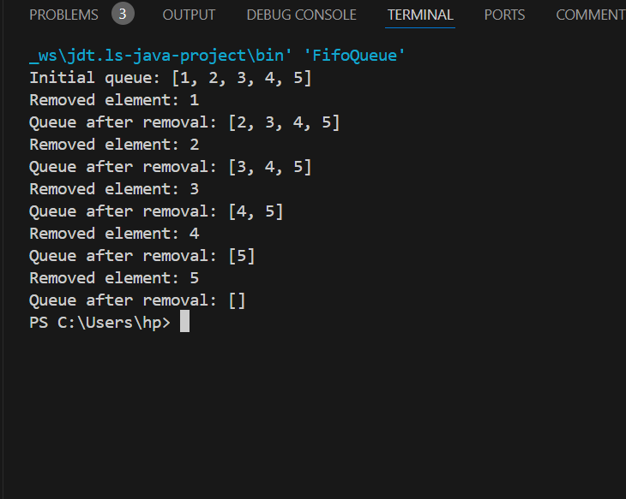

import java.util.*;

public class SSTF {

public static int calculateTotalSeekTime(int[] requests, int head) { List<Integer> requestList = new ArrayList<>();
for (int request : requests) { requestList.add(request);
}
int totalSeekTime = 0;
int currentHeadPosition = head; while (!requestList.isEmpty()) {
int closestRequestIndex = findClosestRequest(requestList, currentHeadPosition); int closestRequest = requestList.get(closestRequestIndex);
totalSeekTime += Math.abs(currentHeadPosition - closestRequest); currentHeadPosition = closestRequest;
requestList.remove(closestRequestIndex);
}
return totalSeekTime;}
private static int findClosestRequest(List<Integer> requests, int head) { int closestDistance = Integer.MAX_VALUE;
int closestRequestIndex = -1;
for (int i = 0; i < requests.size(); i++) {
int distance = Math.abs(requests.get(i) - head); if (distance < closestDistance) {
closestDistance = distance; closestRequestIndex = i}

return closestRequestIndex;
}

public static void main(String[] args) {
Scanner scanner = new Scanner(System.in);

System.out.print("Enter the number of disk requests: "); int numRequests = scanner.nextInt();

int[] requests = new int[numRequests];
System.out.print("Enter the disk requests: "); for (int i = 0; i < numRequests; i++) {
requests[i] = scanner.nextInt();
}

System.out.print("Enter the initial head position: "); int head = scanner.nextInt();

int totalSeekTime = calculateTotalSeekTime(requests, head);

System.out.println("Total Seek Time: " + totalSeekTime);
}
}

import java.util.*; class Scan
{
static int size = 8;
static int disk_size = 200;
static void SCAN(int arr[], int head, String direction)
{
int seek_count = 0;
int distance, cur_track;
Vector<Integer> left = new Vector<Integer>(),
right = new Vector<Integer>(); Vector<Integer> seek_sequence = new Vector<Integer>();
if (direction == "left")
left.add(0);
else if (direction == "right")
right.add(disk_size - 1); for (int i = 0; i < size; i++)
{
if (arr[i] < head)
left.add(arr[i]); if (arr[i] > head)
right.add(arr[i]);
}
Collections.sort(left); Collections.sort(right); int run = 2;
while (run-- >0)
{
if (direction == "left"{

for (int i = left.size() - 1; i >= 0; i--)
{
cur_track = left.get(i);
seek_sequence.add(cur_track); distance = Math.abs(cur_track - head); seek_count += distance;
head = cur_track;
}
direction = "right";
}
else if (direction == "right")
{
for (int i = 0; i < right.size(); i++)
{
cur_track = right.get(i);
seek_sequence.add(cur_track); distance = Math.abs(cur_track - head); seek_count += distance;
head = cur_track;
}
direction = "left";
}
}
System.out.print("Total number of seek operations = "
+ seek_count + "\n"); System.out.print("Seek Sequence is" + "\n");
for (int i = 0; i < seek_sequence.size(); i++)
{
System.out.print(seek_sequence.get(i) + "\n");
}}

public static void main(String[] args)
{ int arr[] = { 176, 79, 34, 60,
92, 11, 41, 114 };
int head = 50;
String direction = "left";

SCAN(arr, head, direction);
}
}

There is out put
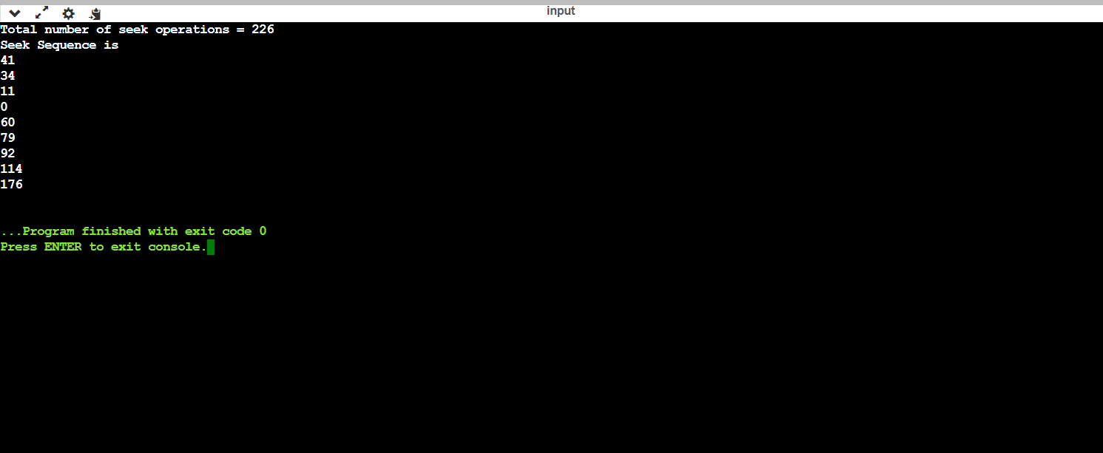
Import java.util.*; class Cscan {
static int size = 8;
static int disk_size = 200;
public static void CSCAN(int arr[], int head)
{
int seek_count = 0;
int distance, cur_track;
Vector<Integer> left = new Vector<Integer>(); Vector<Integer> right = new Vector<Integer>(); Vector<Integer> seek_sequence
= new Vector<Integer>(); left.add(0);
right.add(disk_size - 1); for (int i = 0; i < size; i++) {
if (arr[i] < head)
left.add(arr[i]); if (arr[i] > head)
right.add(arr[i]);
}
Collections.sort(left); Collections.sort(right);
for (int i = 0; i < right.size(); i++) { cur_track = right.get(i);
seek_sequence.add(cur_track); distance = Math.abs(cur_track - head); seek_count +=distancehea=cur_track;
}
head = 0;

seek_count += (disk_size - 1); for (int i = 0; i < left.size(); i++) {
cur_track = left.get(i);
seek_sequence.add(cur_track); distance = Math.abs(cur_track - head); seek_count += distance;
head = cur_track;
}
System.out.println("Total number of seek "
+ "operations = " + seek_count); System.out.println("Seek Sequence is");
for (int i = 0; i < seek_sequence.size(); i++) {
System.out.println(seek_sequence.get(i));
}
}
public static void main(String[] args) throws Exception
{
int arr[] = { 176, 79, 34, 60, 92, 11, 41, 114 };
int head = 50;
System.out.println("Initial position of head: "
+ head);

CSCAN(arr, head);
}
}

